Experiment 5: Erode an Image using Erode Function
Software / Tools: Python · OpenCV (cv2) · NumPy

AIM
To read an image and apply the morphological Erosion operation to shrink bright regions.
ALGORITHM
1. Import OpenCV and NumPy.
2. Read the input image.
3. Define a structuring element (kernel), e.g. a 5x5 matrix of ones.
4. Apply cv2.erode() on the image using the kernel.
5. Display and save the eroded image.
PROGRAM (SOURCE CODE)
import cv2
import numpy as np

img = cv2.imread("image.jpg")
kernel = np.ones((5, 5), np.uint8)

# Apply Erosion
eroded_img = cv2.erode(img, kernel, iterations=1)

cv2.imwrite("eroded_output.jpg", eroded_img)
cv2.imshow("Eroded Image", eroded_img)
cv2.waitKey(0)
cv2.destroyAllWindows()

OUTPUT
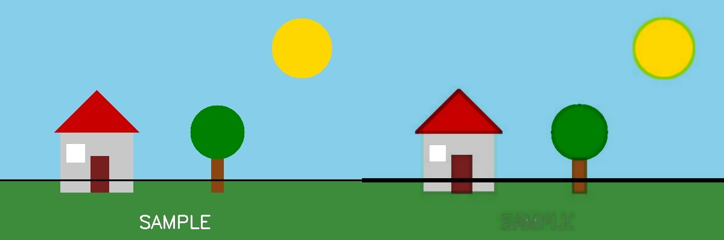
Fig. 5 — Output of Experiment 5: Erode an Image using Erode Function.
RESULT
Read an image and apply the morphological Erosion operation to shrink bright regions — completed successfully, as demonstrated in the output shown above.

